String Operations

# ASCII() CHAR()

• Ascii code value will come as • Character will come as output output for a character for given Ascii code or integer.

expression.

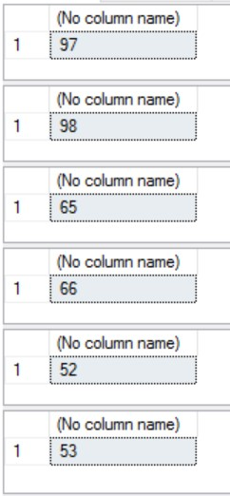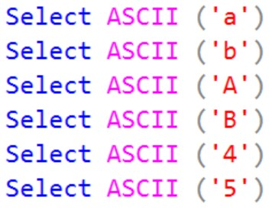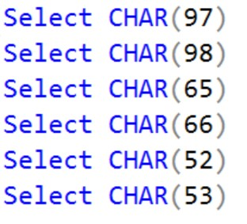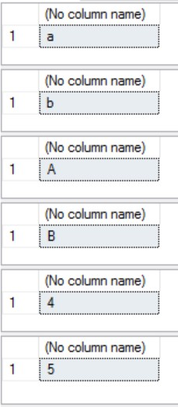

# NCHAR()

• Unicode character will come as output for a given integer.

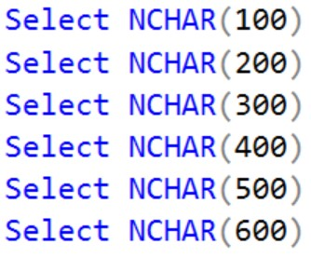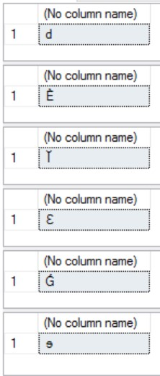

# CHARINDEX()

• Starting position for given search expression will come as output in a given string expression.

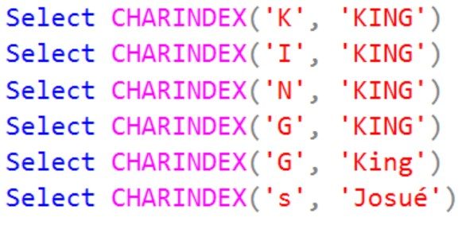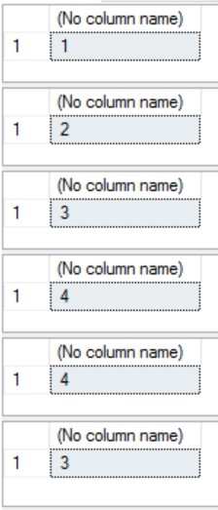

## LEFT**() RIGHT()**

• Left part of the given string till • Right part of the given string till the specified number of the specified number of characters will come as output characters will come as output for a given string. for a given string.

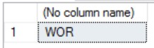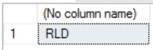

# SUBSTRING()

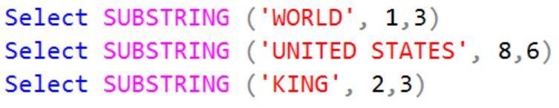• Part of a string based on the start position value and length value will come as output for a given string. 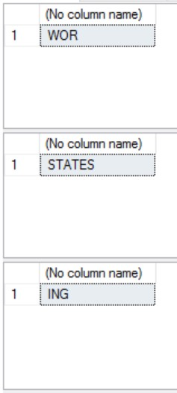

# LEN()

• Number of characters will come as output for a given string expression.

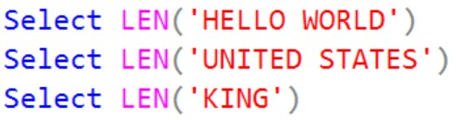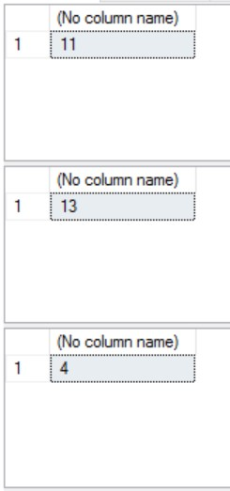

## LOWER() UPPER()

• Lowercase string will come as • Uppercase string will come as output for a given string data. output for a given string data.

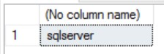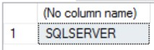

## LTRIM() RTRIM()

• String expression will come as output • String expression will come as output for a given string data after removing for a given string data after removing leading blanks. trailing blanks.

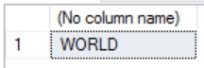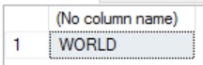

# REPLACE()

• String expression will come as output for a given string data after replacing all occurrences of specified character with specified character.

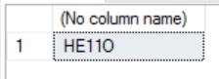

# REPLICATE()

• Repeat string expression will come as output for a given string data with specified number of times.

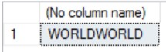

# REVERSE()

• Reverse string expression will come as output for a given string data.

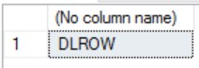

# SOUNDEX()

• Returns four-character (SOUNDEX) code to evaluate the similarity of two given strings.



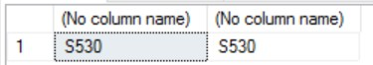

# DIFFERENCE()

• Returns an integer value that indicates the difference between the SOUNDEX values of two character expressions.

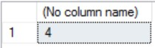

# SPACE()

• Integer value will come as output of given two expressions.

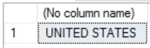

# STUFF()

• String expression will come as output for a given string data after replacing from starting character till the specified length with specified character.

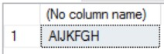

# STR()

• Character data will come as output for the given numeric data.

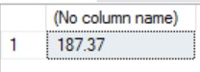

# UNICODE()

• Integer value will come as output for the first character of given expression.

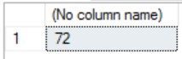

# QUOTENAME()

• Given string will come as output with the specified delimiter.

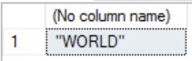

# PATINDEX()

• Returns the starting position of the first occurrence of a pattern in a specified expression, or zeros if the pattern is not found, on all valid text and character data types.

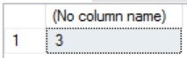

# FORMAT()

• Given expression will come as output with the specified format.

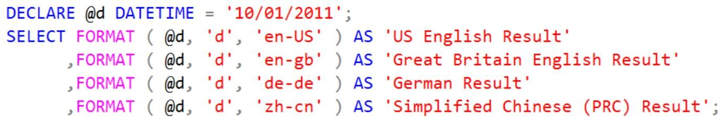

# CONCAT()

• Single string will come as output after concatenating the given parameter values.

